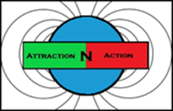 AttractionNAction Inc.
THE PANTHER POWERBELT SYSTEM
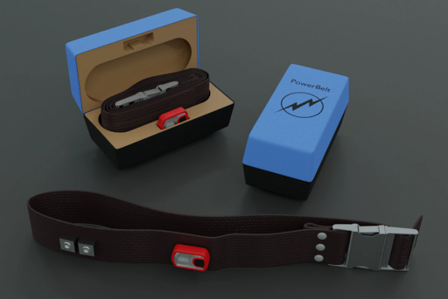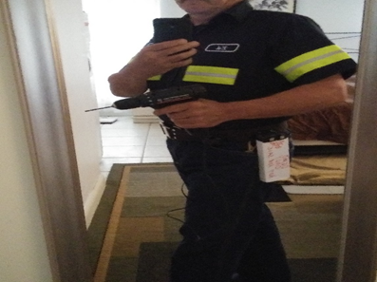
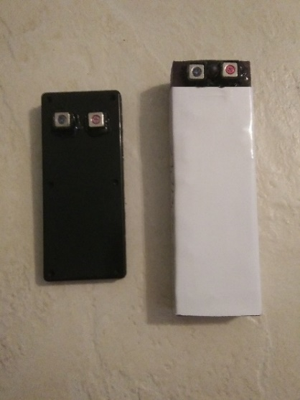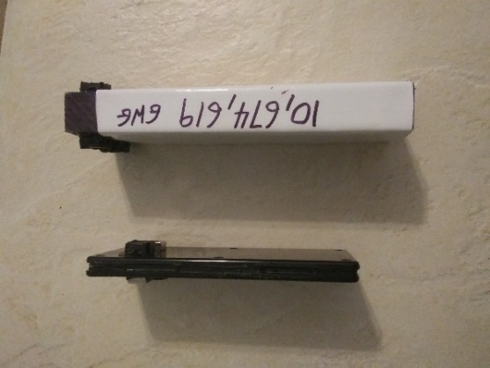
The PANTHER POWERBELT SYSTEM provides a powerful and environmentally friendly way to power hand tools, wireless Xbox or PlayStation controllers or recharge smartphones. The system delivers high-end performance, power, precision as well as versatility. The PANTHER POWERBELT SYSTEM was designed for portable power. The unit is very easy to use. There are no complicated connections. Just strap on the belt. Connect a GamePack2k for gaming or a WorkPack5k for power tools. It’s that easy.
Our PANTHER POWERBELT SYSTEM is also scalable. You can increase the power and energy as needed by connecting more powerpacks to the belt. The PANTHER POWERBELT SYSTEM will be able to hookup 6 powerpacks at the same time for heavy power demands. Do not mix and match the powerpacks. They have different voltages. The black powerpack is for gaming (12V) and the white powerpack is for work (24V).
The PANTHER POWERBELT SYSTEM does not use any type of battery cell technology. This product uses AttractionNAction Graphene Supercapacitor Powerpacks with patented graphene coated magnetic connectors. AttractionNAction offers the only Graphene Supercapacitor Powerpacks on the market today! The powerpacks have an incredible lifespan of 20 years or 500,000 charges. The powerpacks have a DoD (Depth of discharge) of 100% meaning you can fully drain the powerpacks of all their energy without damaging or reducing their lifespan. No other product even comes close. With the PANTHER POWERBELT SYSTEM, you get unmatched performance.
The PANTHER POWERBELT SYSTEM also comes with our AttractionNAction Cheetah Charger which is a custom charger built and designed specifically for charging the unit. It only takes 45 to 90 minutes to fully charge the powerpacks while increasing their temperature by only 1 or 2 degrees. The user must ONLY use this charger to charge the PANTHER POWERBELT SYSTEM. The powerpacks never overheat while charging or discharging energy. There are no risks of explosion with AttractionNAction Graphene Supercapacitor technology. You can also charge the powerpacks with our Solar Panel Module in about 160–320 minutes in strong direct sunlight. Even a tiny bit of light will trickle energy into the powerpacks. Our Supercapacitor Powerpacks are extremely efficient when it comes to solar charging.
In a toxic sea of Lead and Lithium-ion batteries powering consumer electronics, AttractionNAction offers the only green solution to powering electronic devices and we do it while outperforming all other types of batteries currently on the market. We are clean, green and safe. AttractionNAction is the next step in green power storage for today’s technology.
________________________________________________________________________________________________________________SPECS:
Product: PANTHER POWERBELT SYSTEM
Dimensions: Belt 40 inches long x 2 inches wide
GamePack2k 6.375 x 2.75 x .375 inch
WorkPack5k 8.25 x 2.75 x 1 inch
WEIGHT: 1.2 POUNDS (for the belt)
.275 POUNDS (for the GamePack2k)
2.35 POUNDS (for the WorkPack5k)
MATERIALS: Belt Heavy duty Nylon
GamePack2k Light weight PVC Casing
WorkPack5k Heavy Duty UHMW Casing
TERMINALS: Magnetic connector ports x 7 (3 input ports on each hip and port 7 is for output)
COLOR: Belt Brown
GamePack2k Black
WorkPack5k White
POWER STORAGE TECHNOLOGY: AttractionNAction Graphene Supercapacitors
VOLTAGE: GamePack2k 12V
WorkPack5k 24V
AMP HOUR CAPACITY: GamePack2k 2 ah
WorkPack5k 5 ah
MAH CAPACITY: GamePack2k 2000 mah
WorkPack5k 5000 mah
DEPTH OF DISCHARGE (DoD): 100%
CYCLES @ 100% DoD: 500,000
SHORT CIRCUIT PROTECTION: YES (each powerpack has integrated short circuit protection)
CHARGING TIME: GamePack2k fully charges in 45 minutes (with PPTC thermal protection)
WorkPack5k fully charges in 90 minutes (with PPTC thermal protection)
RETAIL PRICE: Panther Powerbelt $39.95
GamePack2k $34.95
WorkPack5k $54.95
Cheetah Charger $44.95 (variable voltage 6V DC, 12V DC, 18V DC, 24V DC)
ACCESSORIES: Solar Panel Module $19.95 (connects to the belt just like a powerpack)
PowerDrill $34.95 (to be used ONLY with WorkPack5k)
BUNDLES: GamePack Bundle: $109.95
1 x Panther Powerbelt
1 x GamePack2k
1 x Cheetah Charger
WorkPack Bundle: $159.95
1 x Panther Powerbelt
1 x WorkPack5k
1 x Cheetah Charger
1 x PowerDrill (to be used ONLY with WorkPack5k)

