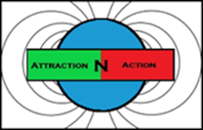 AttractionNAction

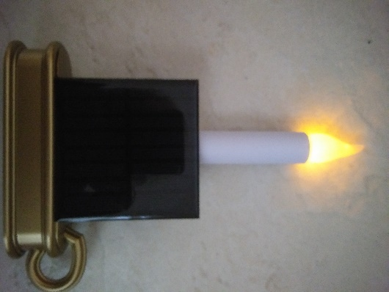
THE SOLAR SECURITY WINDOW CANDLE

Our SOLAR SECURITY WINDOW CANDLE is a basic home security device. It is also used for home décor. There are no complicated connections to make and is absolutely maintenance free.
The SOLAR SECURITY WINDOW CANDLE uses AttractionNAction Magnetic Power Cells. We do not use ANY kind of battery cell technology. We are new and unique. AttractionNAction offers the only Graphene Supercapacitor Magnetic Power Cells on the market today! These Magnetic Power Cells have an incredible lifespan of 20 years or 500,000 charging cycles. No other product even comes close.
The SOLAR SECURITY WINDOW CANDLE charges itself with the attached solar panel and you never have to worry about charging the unit. Even a tiny bit of light will trickle energy into the Magnetic Power Cells. Last but not least, there are no explosion risks with our Graphene Supercapacitor technology. The unit never overheats while charging or discharging energy. It is totally safe.
In a toxic sea of Lead and Lithium-ion batteries, AttractionNAction offers the only green solution to power storage and we do it while outperforming all other types of batteries currently on the market. We are clean, green and safe. AttractionNAction is the next step in green power storage for today’s technology.

________________________________________________________________________________________________________________
SPECS:
Product: SOLAR SECURITY WINDOW CANDLE
Dimensions: Base 6.375 x 1.63 x 1.125 inches
Black solar panel 3.35 x 3.35 x .062 inches
Candle 9 inches long with a 1-inch diameter
WEIGHT: .375 lbs
MATERIALS: PVC
COLOR: Brass colored base
Black solar panel
BULB: Yellow 5mm LED 11 mA
POWER STORAGE TECHNOLOGY: 2 x AttractionNAction MAGNETIC POWER CELLS (Classic)
VOLTAGE: 2.7V (each)
AMP HOUR CAPACITY: 2 (1 ah each)
WATTHOUR CAPACITY: 5.4Wh (2.7Wh for candle and 2.7Wh for security module)
DEPTH OF DISCHARGE (DoD): 100%
CYCLES @ 100% DoD: 500,000
CHARGING: Solar charging only. Charges in 2 hours of full direct sunlight. Also charges with artificial
light but at a slower rate.
RETAIL PRICE: $9.95 Basic Unit
$29.95 with security module

